Exercise: Introduction to Version Control

1. Git Setup https://confluence.atlassian.com/bitbucket/set-up-git-744723531.html

Answer: sudo apt-get install git

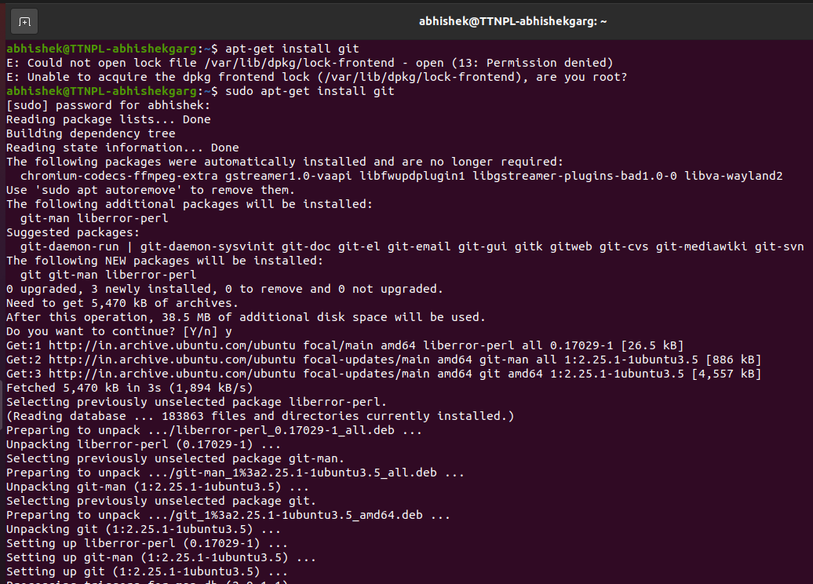

1. Initialize a Git Repository

Answer: Navigate to the desired directory and enter command:-

Git init

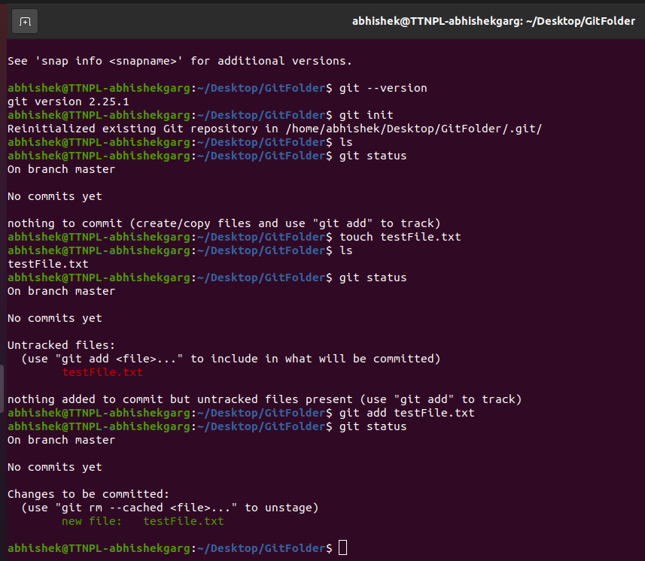

1. Add files to the repository

Answer: touch abc.txt xyz.txt ttn.txt abhi.txt testFile.txt

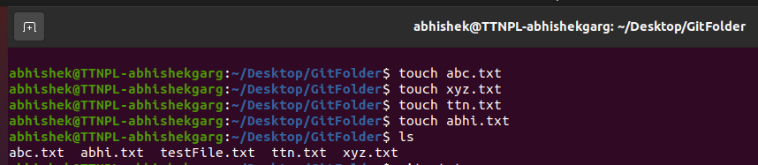

1. Unstage 1 file

Answer: git rm - -cached abc.txt

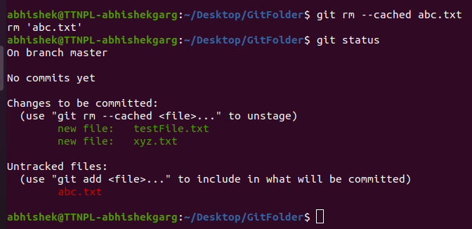

1. Commit the file

Answer: git config - -global user.email “[abhishek.garg@tothenew.com](mailto:abhishek.garg@tothenew.com)”

git config - -global user.name “Abhishek”

git commit -m “Initial Commit”

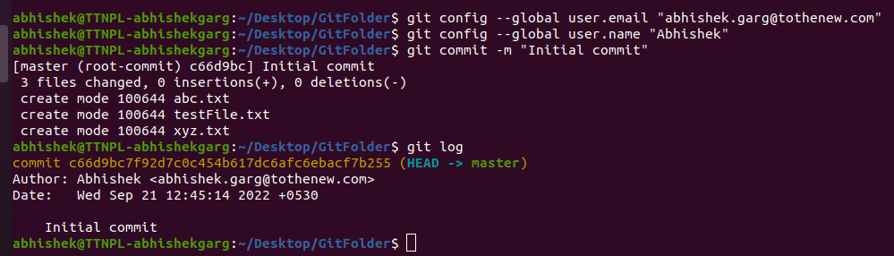

1. Add a remote

Answer: git remote add origin https://github.com/AbhishekGargTTN/mynewrepo.git

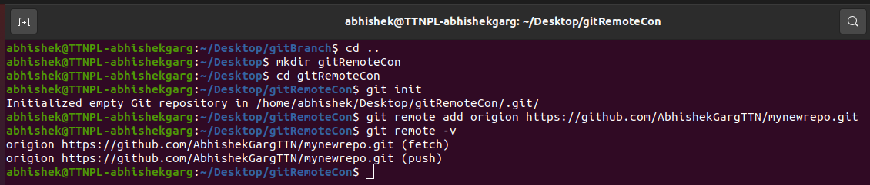

1. Undo changes to a particular file

Answer: git revert 6d44b85

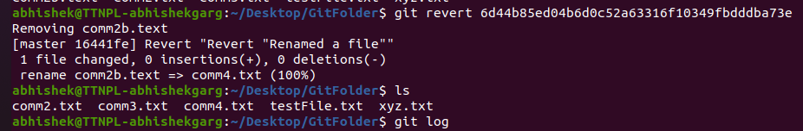

1. Push changes to Github

Answer: git push origin master

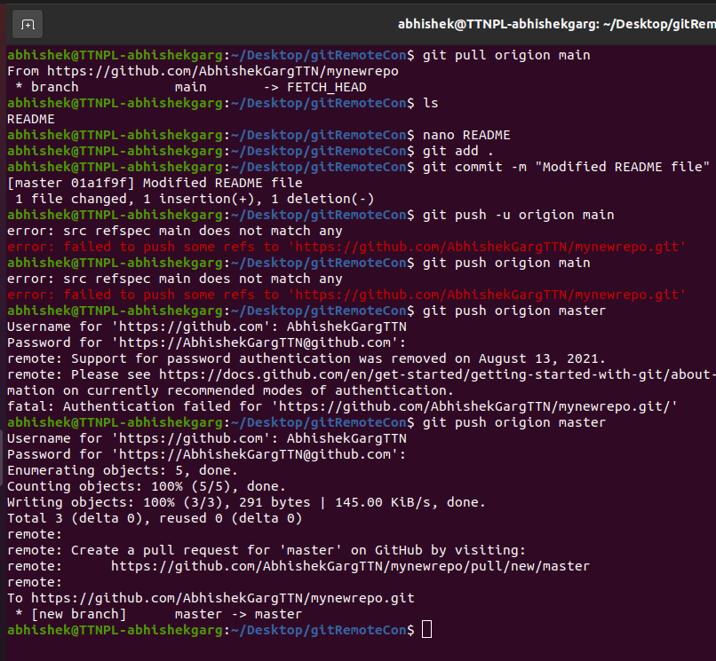

1. Clone the repository

Answer: git clone https://github.com/AbhishekGargTTN/mynewrepo.git

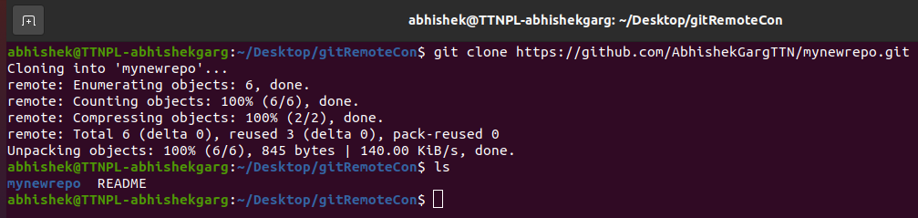

1. Add changes to one of the copies and pull the changes in the other.

Answer:

1. Check differences between a file and its staged version

Answer: git diff --staged

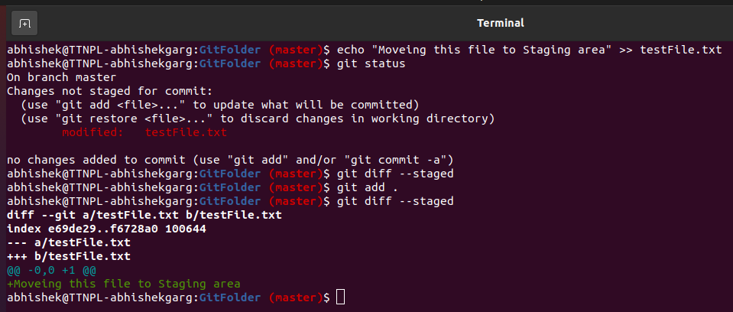

1. Ignore a few files to be checked in

Answer: Create directory .gitignore and add file names to .gitignore

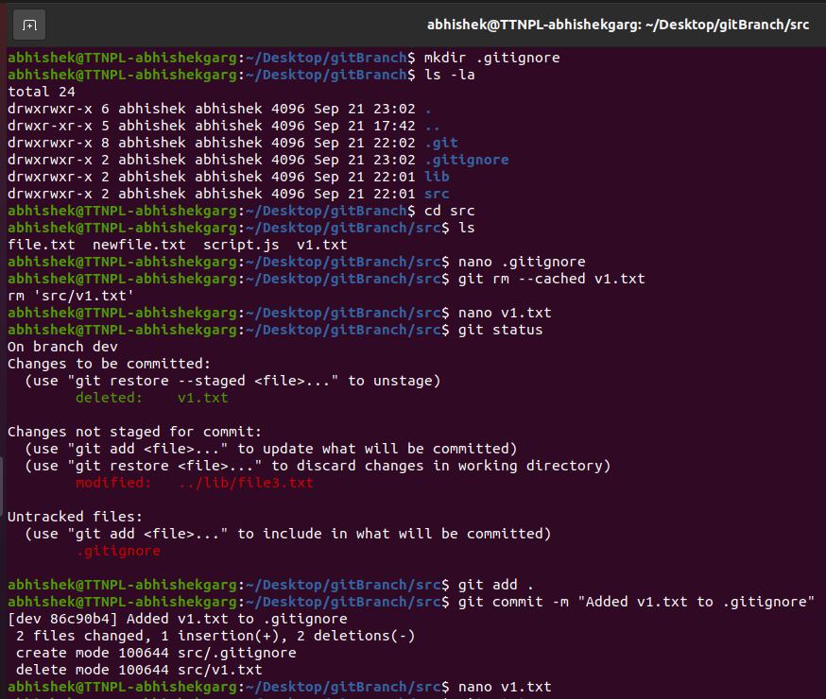

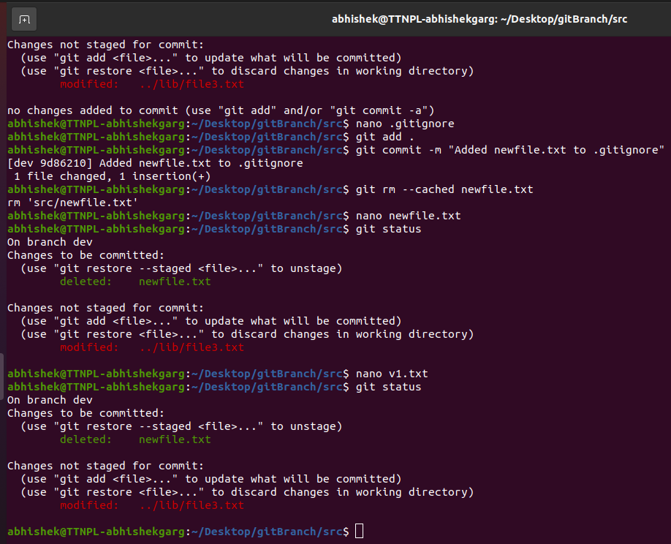

1. Create a new branch.

Answer: git branch dev

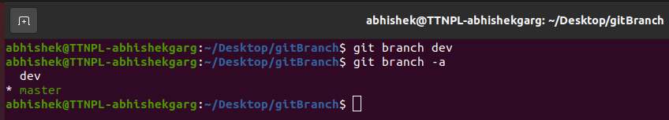

1. Diverge them with commits

Answer: Do some changes to dev branch and commit it

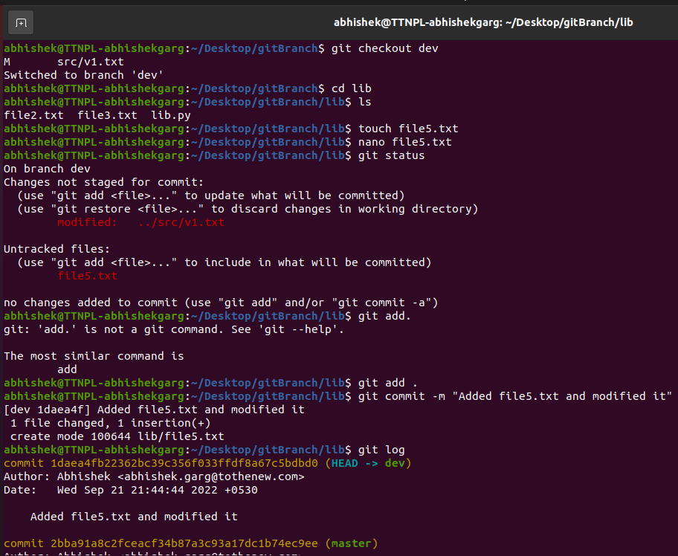

1. Edit the same file at the same line on both branches and commit

Answer: Edit file.txt in master, commit it and then edit file.txt in dev, commit it

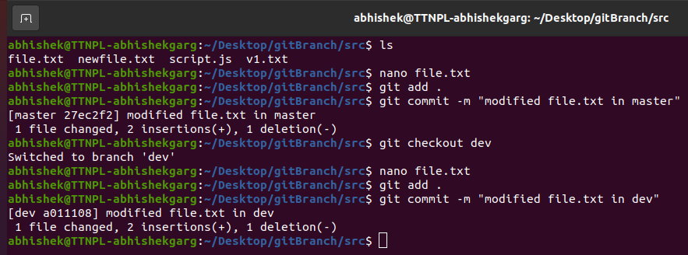

1. Try merging and resolve merge conflicts

Answer:

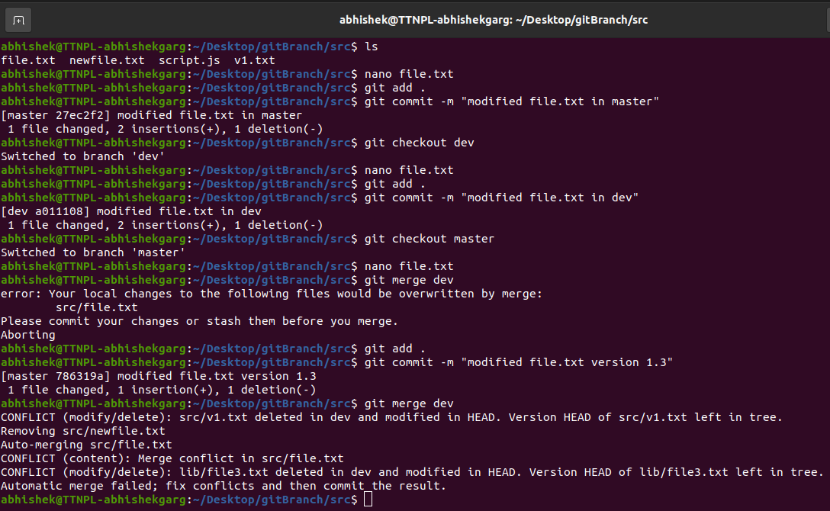

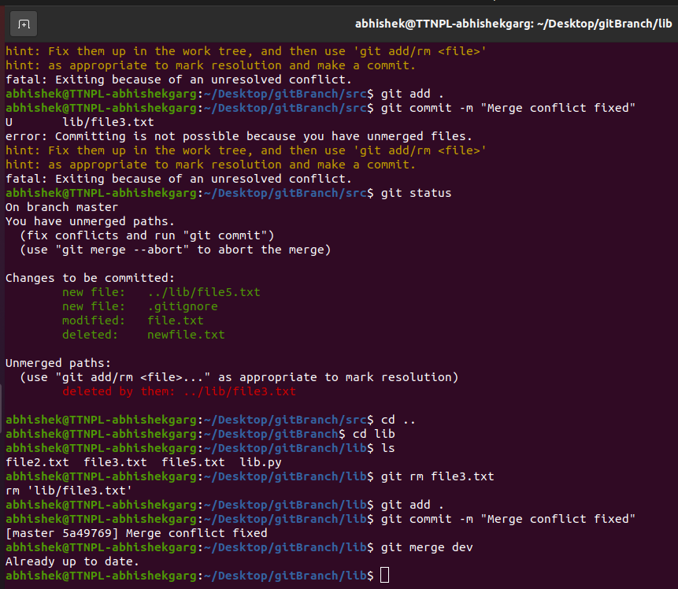

1. Stash the changes and pop them

Answer: git stash save

git checkout dev

git stash pop

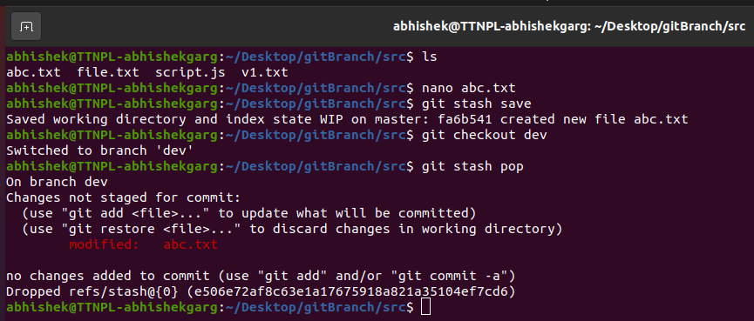

1. Add the following code to your .bashrc file : color_prompt="yes"  
    parse_git_branch() {  
    git branch 2> /dev/null | sed -e '/^[^*]/d' -e 's/* \(.*\)/(\1)/'  
    }  
    if [ "$color_prompt" = yes ]; then  
    PS1='\u@\h\[\033[00m\]:\[\033[01;34m\]\W\[\033[01;31m\] $(parse_git_branch)\[\033[00m\]\$ '  
    else  
    PS1='\u@\h:\W $(parse_git_branch)\$ '  
    fi  
    unset color_prompt force_color_prompt

Answer: nano ~/.bashrc

Copy the code above and paste in .bashrc file and save

